
Foundations of Programming
Assignment No. : 5
PROBLEM STATEMENT:
Write a program in C to perform basic matrix operations such as:
1. Addition of two matrices
2. Saddle point of a matrix
3. Inverse of a matrix
4. Magic square of a matrix
OBJECTIVE:
• To understand matrix representation in C using two-dimensional arrays.
• To implement various matrix operations using C programming.
• To develop logical thinking for solving matrix-based problems.
THEORY:
Matrix operations are widely used in engineering and scientific applications. Addition of matrices involves adding corresponding elements. A saddle point is an element that is the minimum in its row and maximum in its column. The inverse of a matrix exists only for square matrices with non-zero determinant. A magic square is a square matrix in which the sums of elements in each row, column, and diagonals are equal. (ADD Example for 1. Addition of two matrices
2. Saddle point of a matrix
3. Inverse of a matrix
4. Magic square of a matrix
)
ALGORITHM:
1. Start
2. Read the order of the matrix
3. Read elements of the matrices
4. Perform matrix addition
5. Check for saddle point
6. Find inverse of the matrix (if determinant ≠ 0)
7. Check whether the matrix is a magic square
8. Display results
9. Stop

CODE:
#include <stdio.h>

#define MAX 10

int determinant2x2(int a[MAX][MAX]) {
return (a[0][0]*a[1][1] - a[0][1]*a[1][0]);
}

int main() {
int n;
int A[MAX][MAX], B[MAX][MAX], C[MAX][MAX];
int i, j;

/* Read order */
printf("Enter order of the matrix: ");
scanf("%d", &n);

/* Read matrix A */
printf("Enter elements of Matrix A:\n");
for (i = 0; i < n; i++)
for (j = 0; j < n; j++)
scanf("%d", &A[i][j]);

/* Read matrix B */
printf("Enter elements of Matrix B:\n");
for (i = 0; i < n; i++)
for (j = 0; j < n; j++)
scanf("%d", &B[i][j]);

/* Matrix Addition */
for (i = 0; i < n; i++)
for (j = 0; j < n; j++)
C[i][j] = A[i][j] + B[i][j];

printf("\nMatrix Addition Result:\n");
for (i = 0; i < n; i++) {
for (j = 0; j < n; j++)
printf("%d ", C[i][j]);
printf("\n");
}

/* Saddle Point */
int found = 0;
for (i = 0; i < n; i++) {
int min = A[i][0], col = 0;
for (j = 1; j < n; j++) {
if (A[i][j] < min) {
min = A[i][j];
col = j;
}
}

int k;
for (k = 0; k < n; k++) {
if (A[k][col] > min)
break;
}

if (k == n) {
printf("\nSaddle Point: %d at position (%d, %d)", min, i, col);
found = 1;
}
}
if (!found)
printf("\nNo Saddle Point Found");

/* Inverse of Matrix (2x2 only) */
if (n == 2) {
int det = determinant2x2(A);
if (det != 0) {
printf("\n\nInverse of Matrix A:\n");
printf("%.2f %.2f\n",
(float)A[1][1]/det, (float)-A[0][1]/det);
printf("%.2f %.2f\n",
(float)-A[1][0]/det, (float)A[0][0]/det);
} else {
printf("\n\nInverse does not exist (Determinant = 0)");
}
}

/* Magic Square Check */
int sum = 0;
for (j = 0; j < n; j++)
sum += A[0][j];

int magic = 1;
for (i = 1; i < n; i++) {
int rowSum = 0;
for (j = 0; j < n; j++)
rowSum += A[i][j];
if (rowSum != sum) {
magic = 0;
break;
}
}

if (magic)
printf("\n\nMatrix A is a Magic Square");
else
printf("\n\nMatrix A is NOT a Magic Square");

return 0;
}

FLOWCHART:
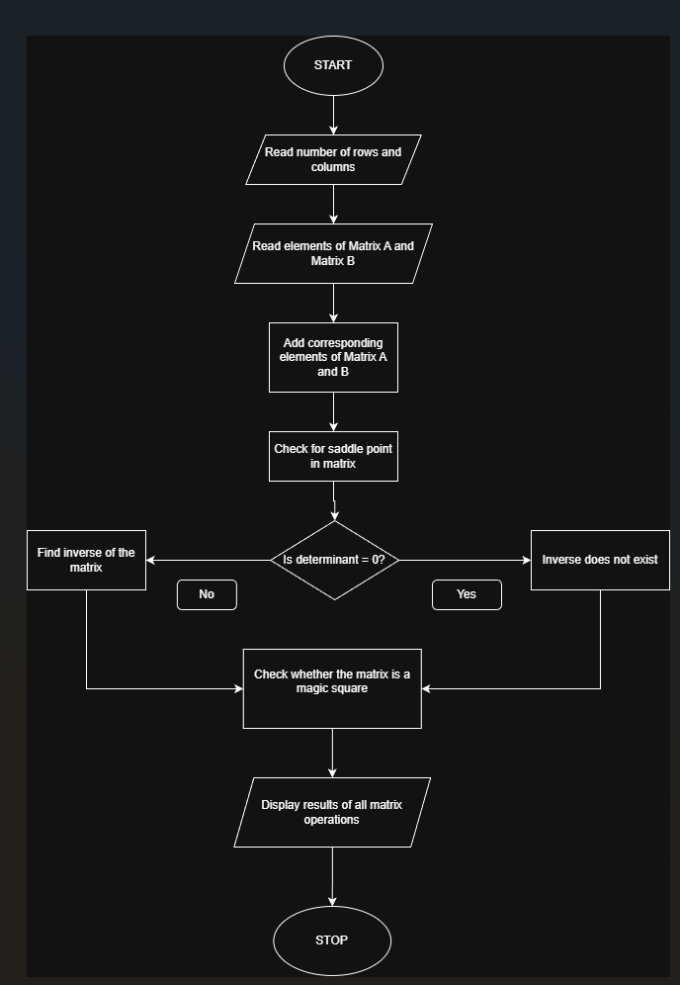

CONCLUSION:
Thus, we have learned how to perform basic matrix operations using C programming and understood their practical applications.

